2.PC (fon windows)
Step1:Go to the website http://www.forticlient.com/ to download the software. Click “Run” to install the software.
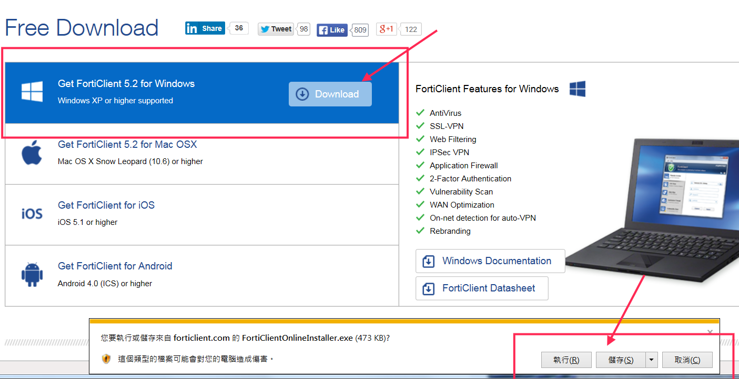

Step2：After download the software, check [ Yes,I have read and accept the ] , then click Next.
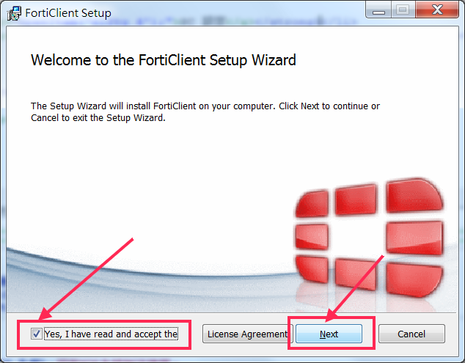

Step3：Click VPN Only then Next.
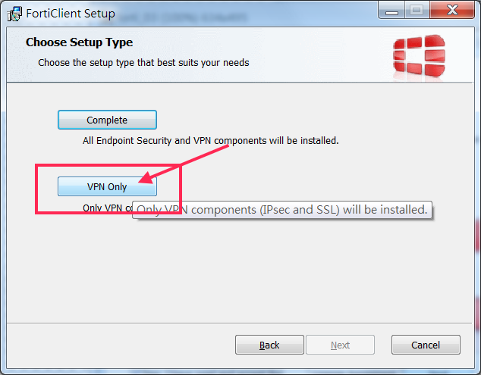

Step4：Confirm the “Destination Folder”, then click Next.
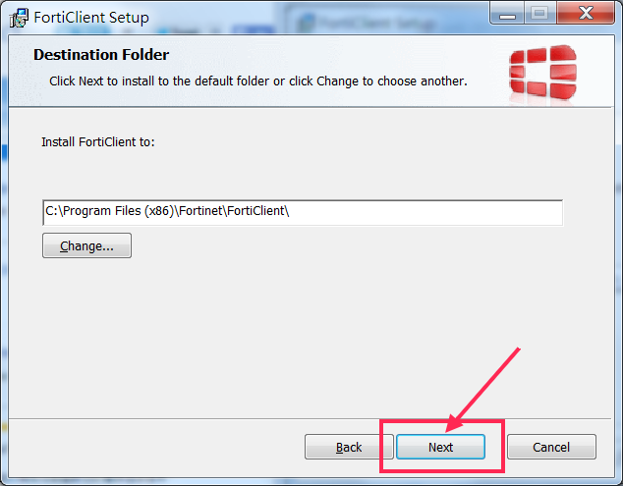

Step5：Click Install to begin the installation.
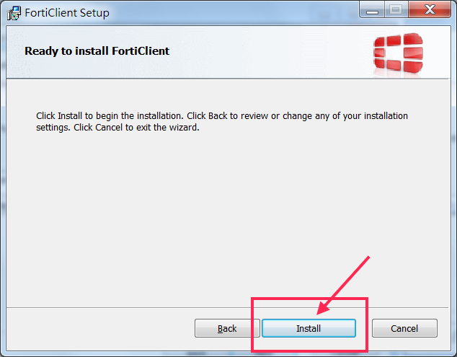

Step6：Click Finish to complete the installation.
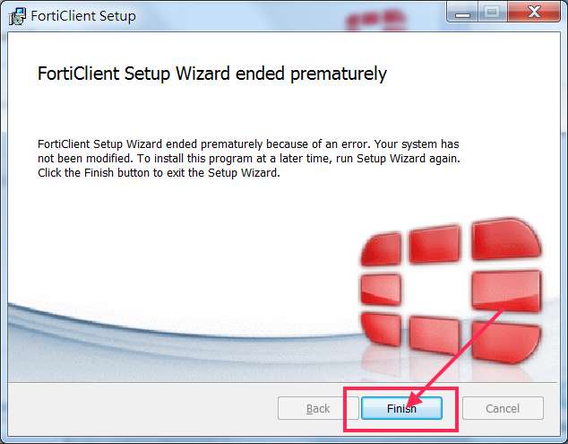

Step7：Run the "FortiClient" program，click 配置 VPN to set up the VPN.
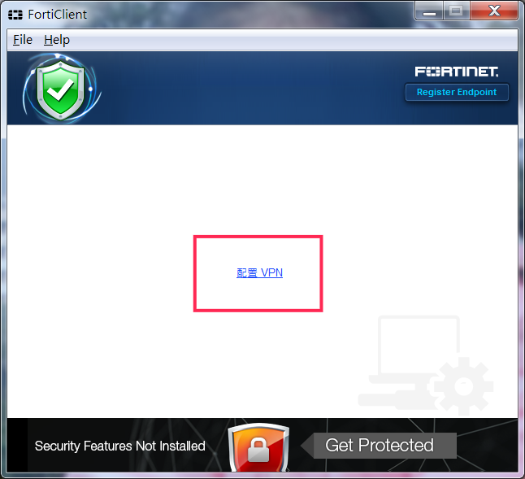

Step8：Please follow the picture to type the following information.140.121.81.181、NTOU SSLVPN、140.121.81.181.
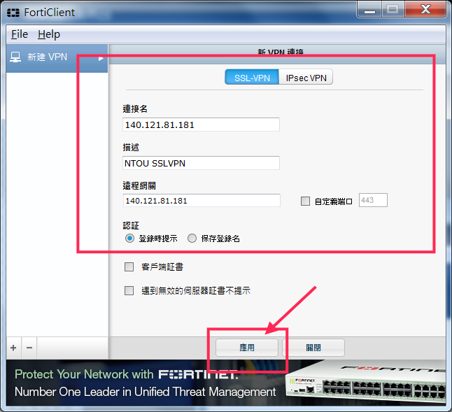

Step9：After set up the VPN, restart to run the FortiClient program.Please type in your email ID (student number) in NTOU and password (passport number).Then click link.
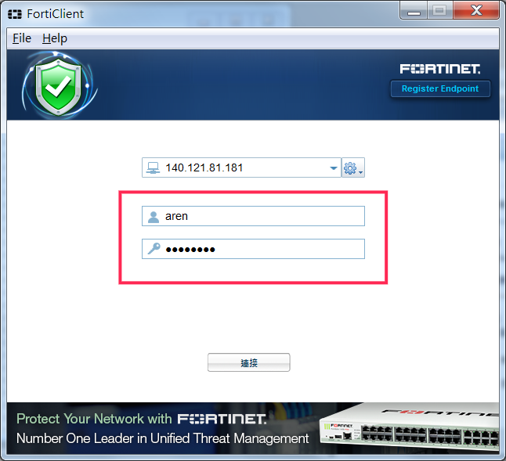

Step10：If you run into the “Security Notice”, please click Yes to continue the process.
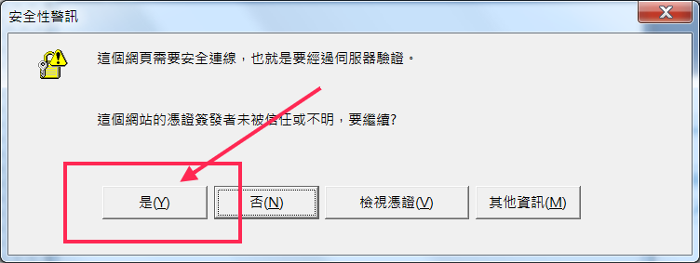Step11： If you want to test the VPN connection, you can go to the website http://www.whatismyip.com/, where IP Address will show you "140.121.81.181".
