1.Tablet (IOS)
Step1： Go to "App Store" and search “forticlient”, then install the APP.
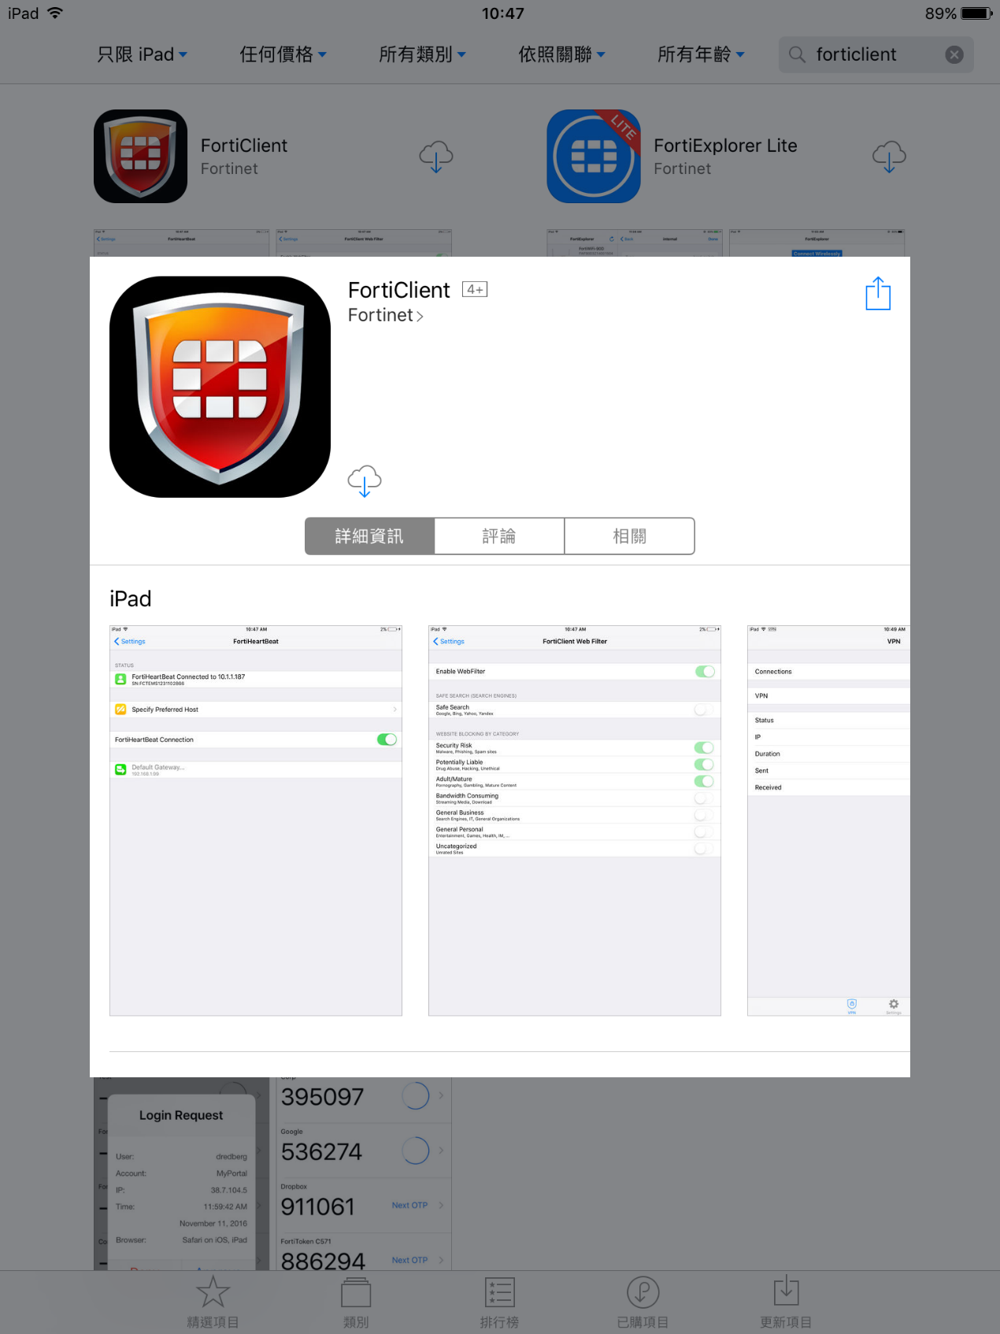

Click OK, got it to continue.
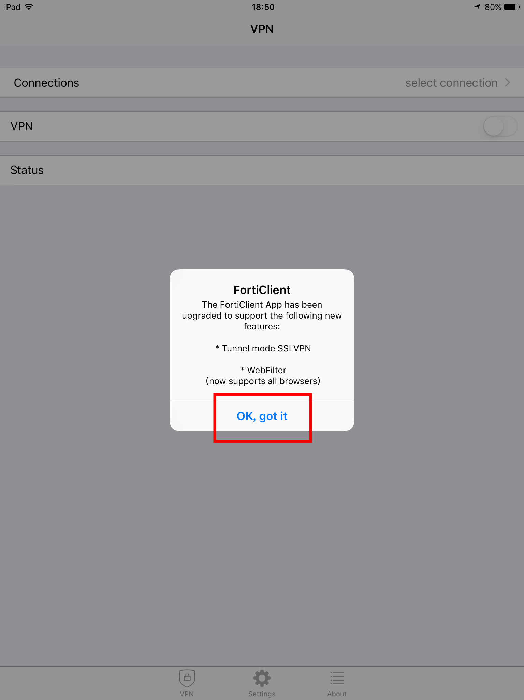

Click Allow to continue.
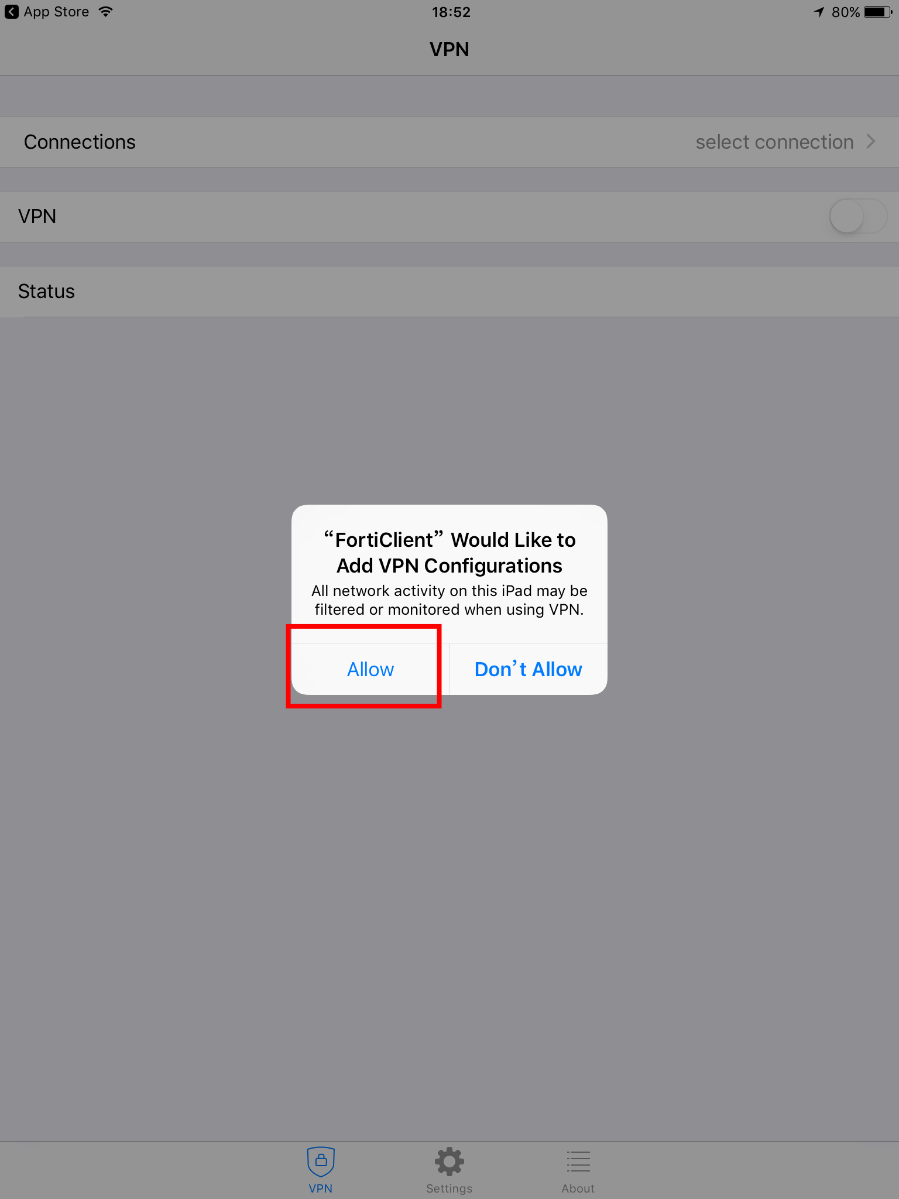

Click Connections to continue.
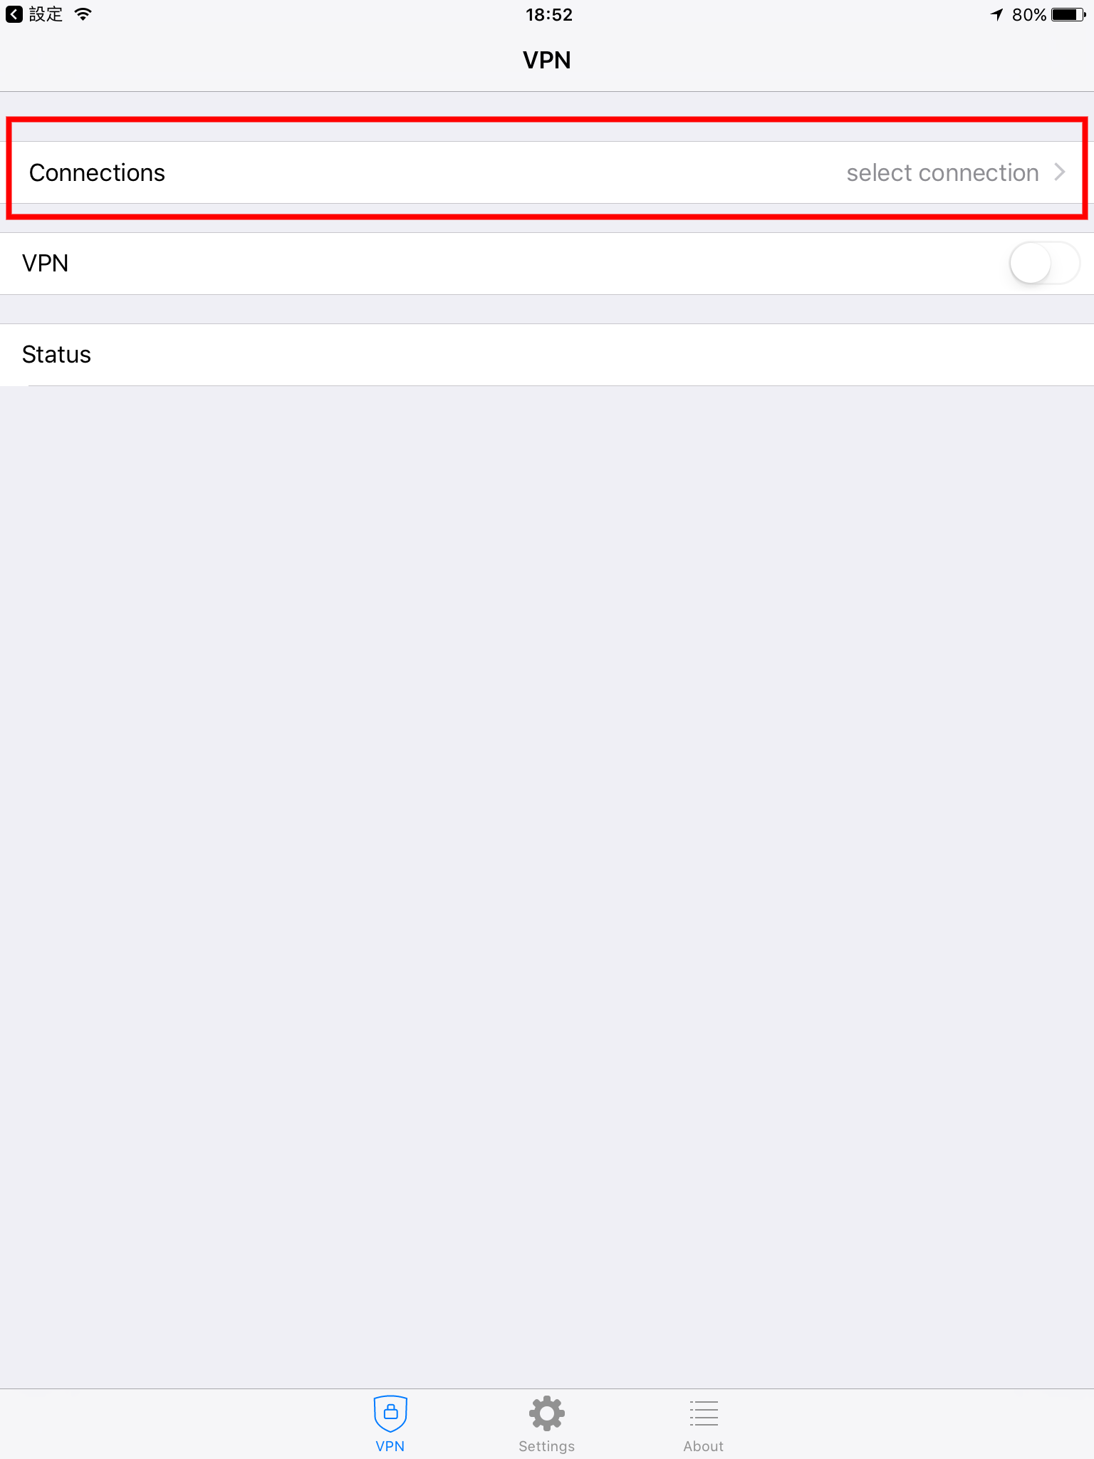

Click Add Connections to continue.
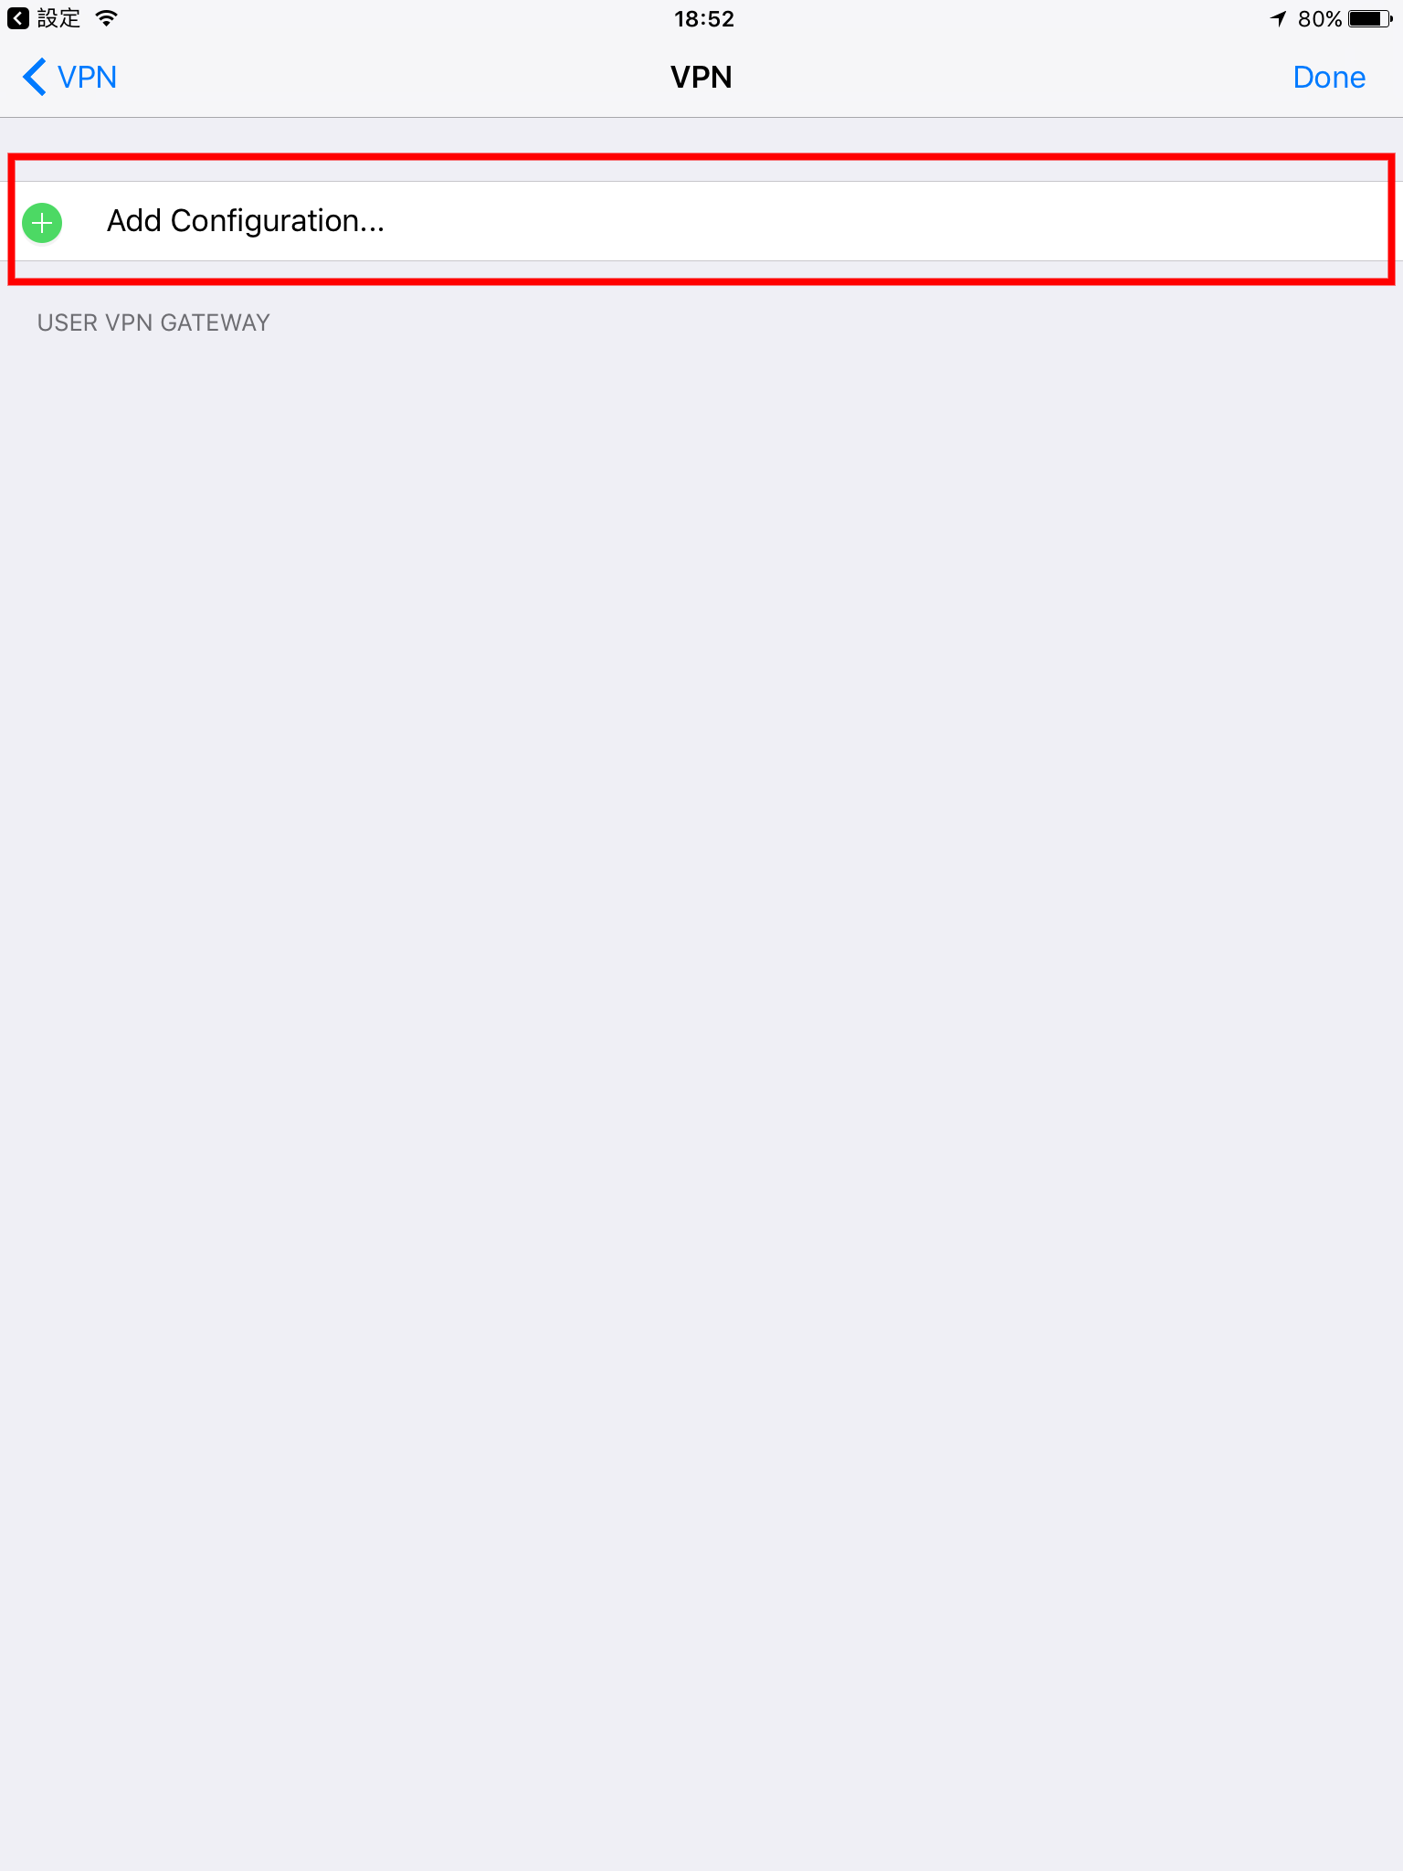

Step2： Type in VPN name (You can set up by yourself).

Type in Host Name 140.121.81.181. Type in User Name and Password, which are your email ID in NTOU, and then click Done
Host 140.121.81.181
User E-mail acount
Password E-mail password
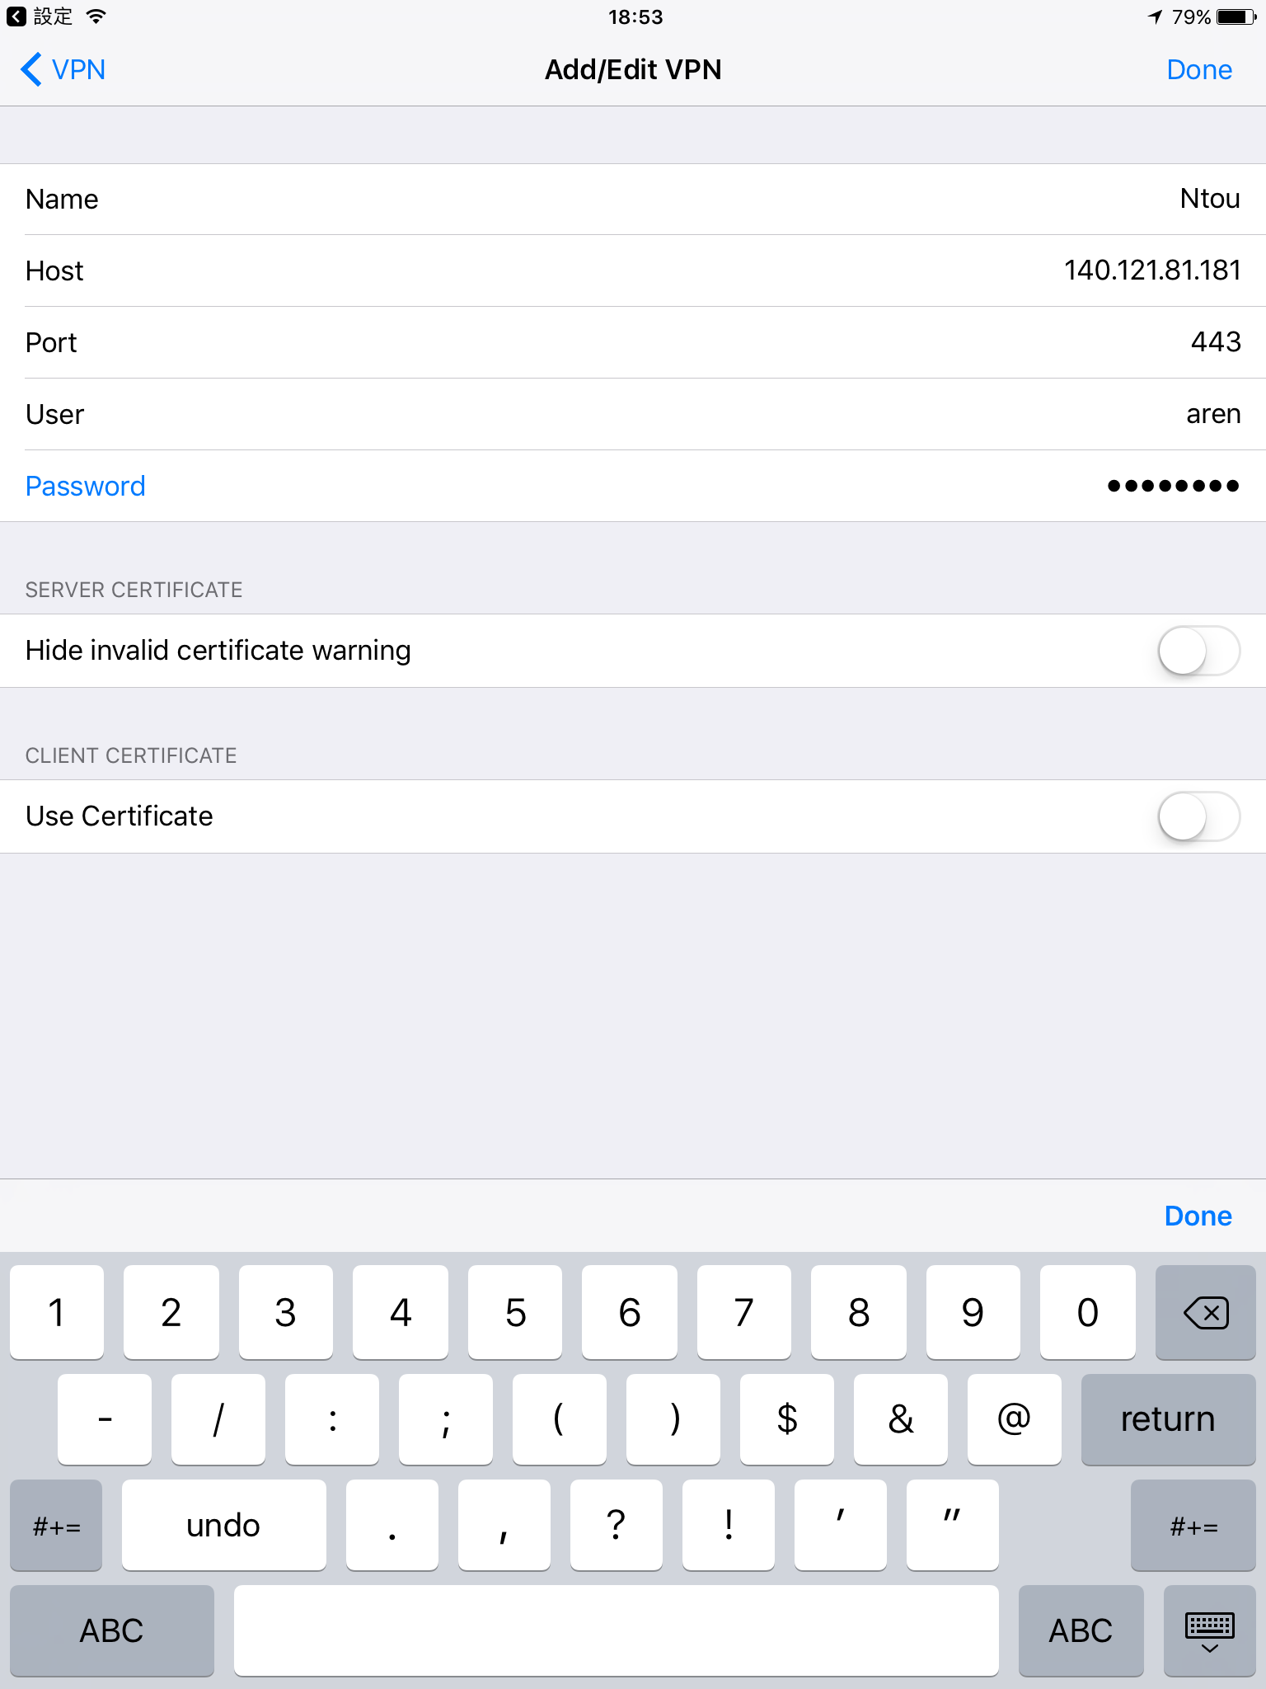
Step3：Setup complete！ Connect
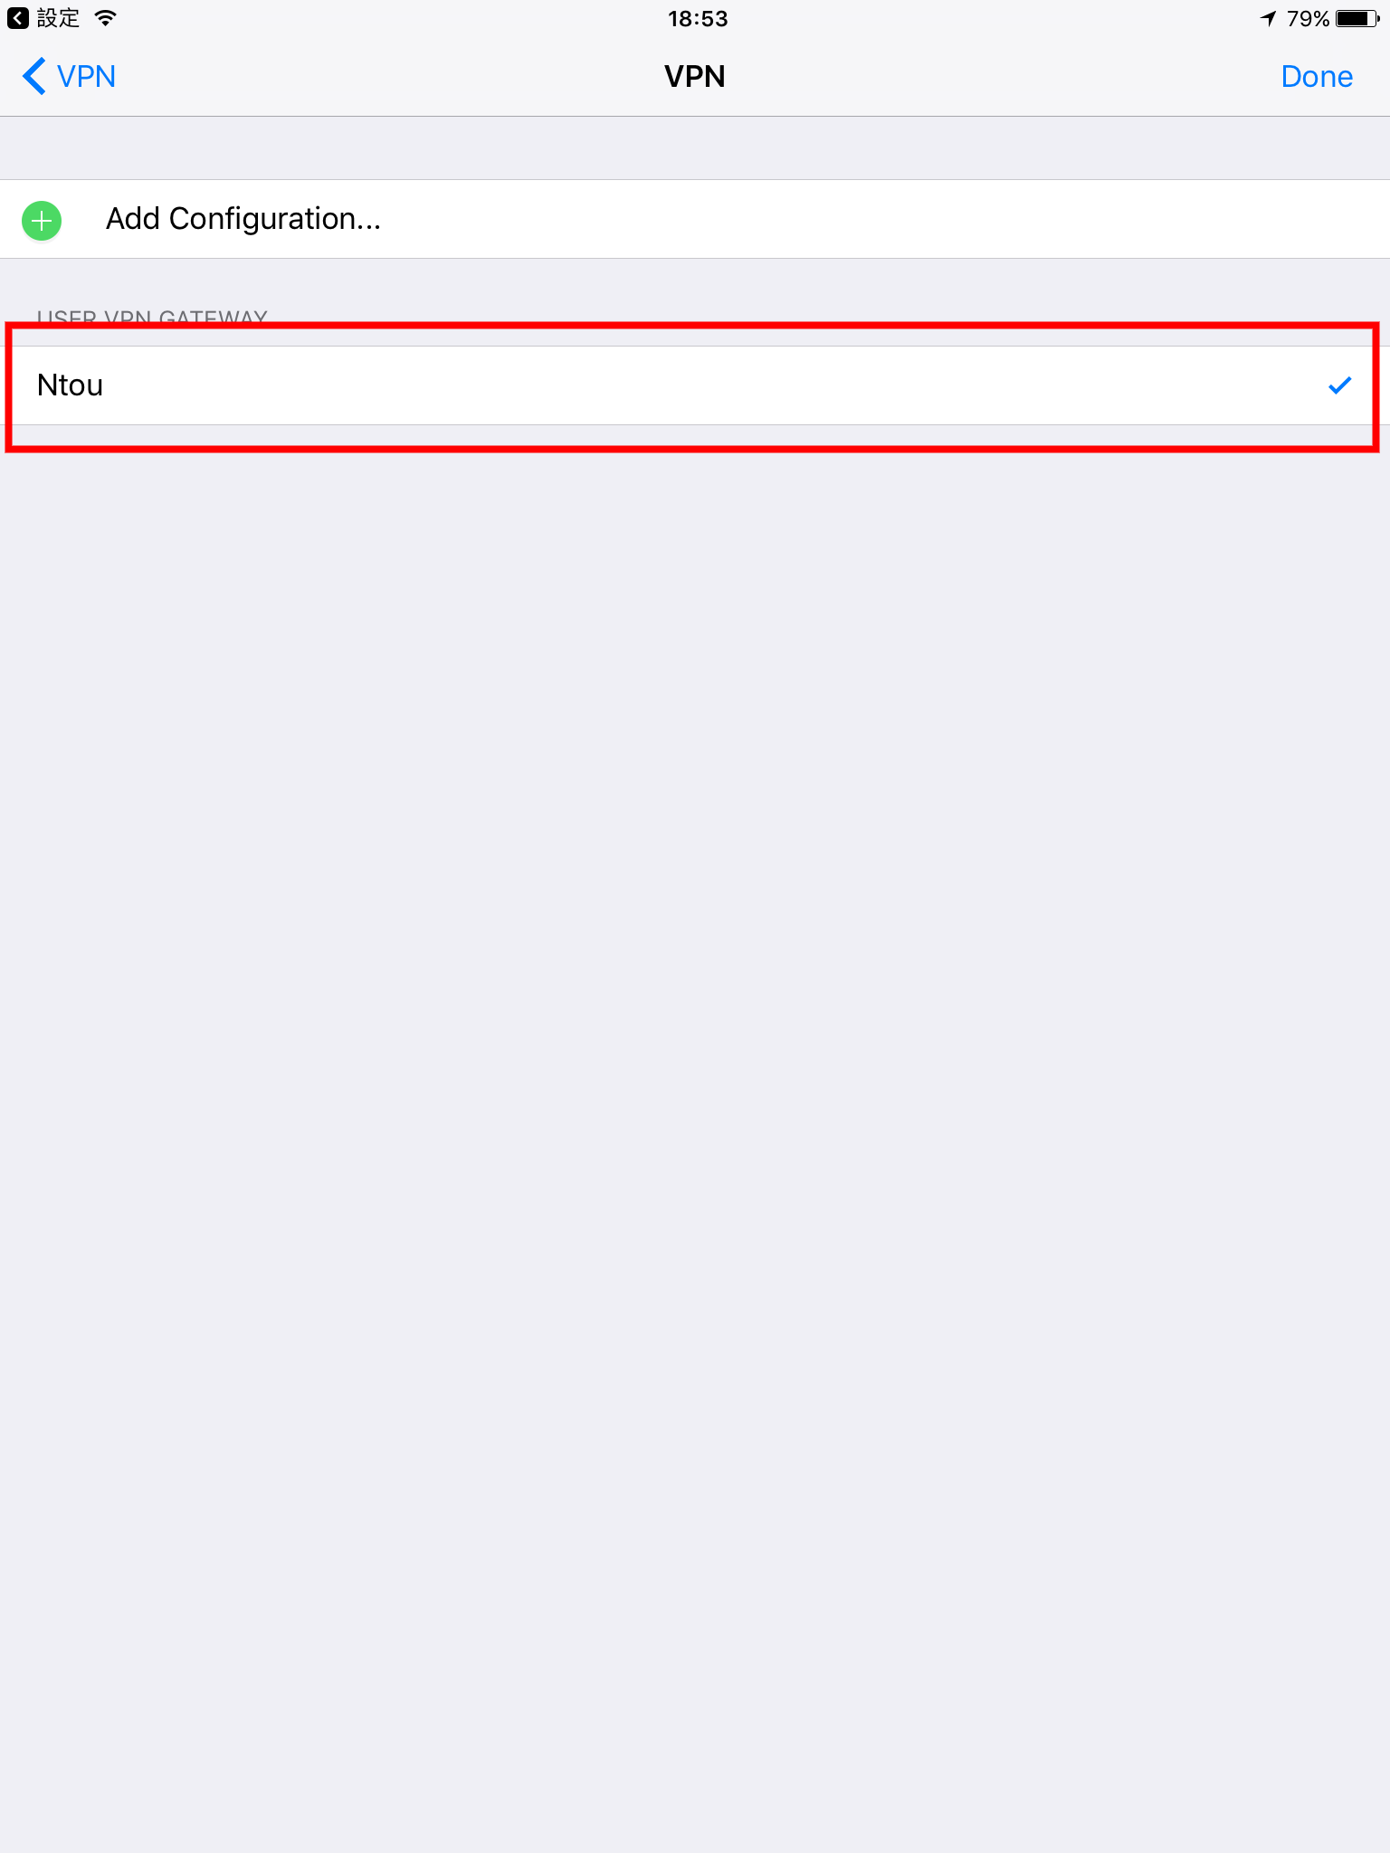

Click OK
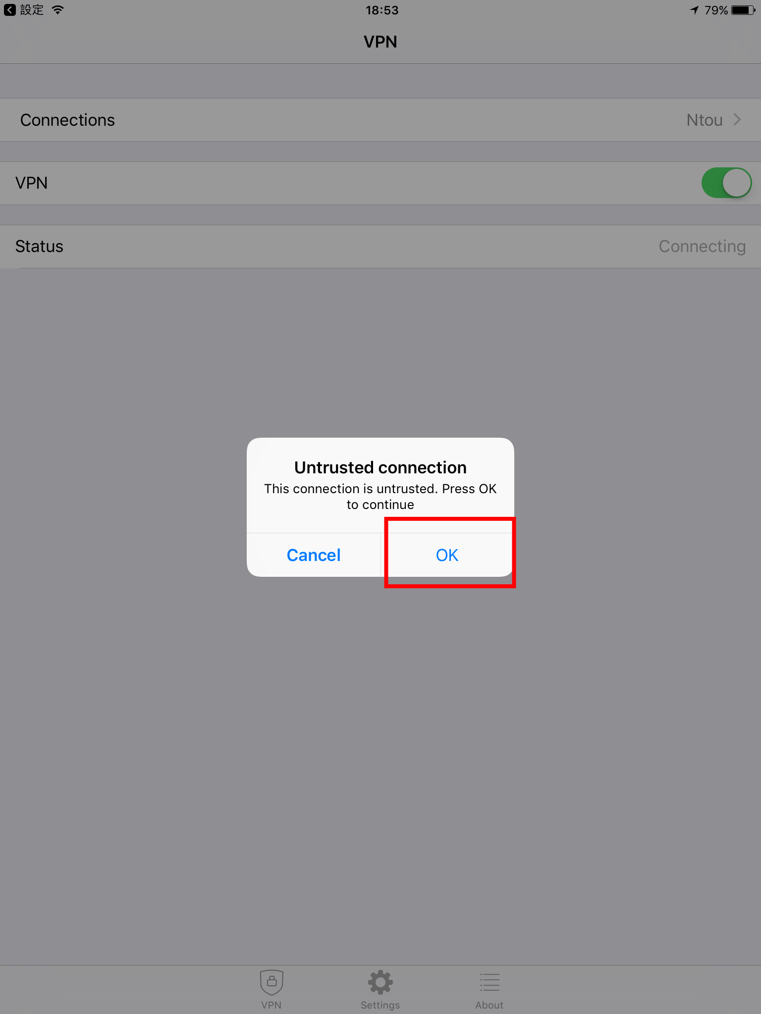

Step5：Connect success! If you finish the process, click VPN.
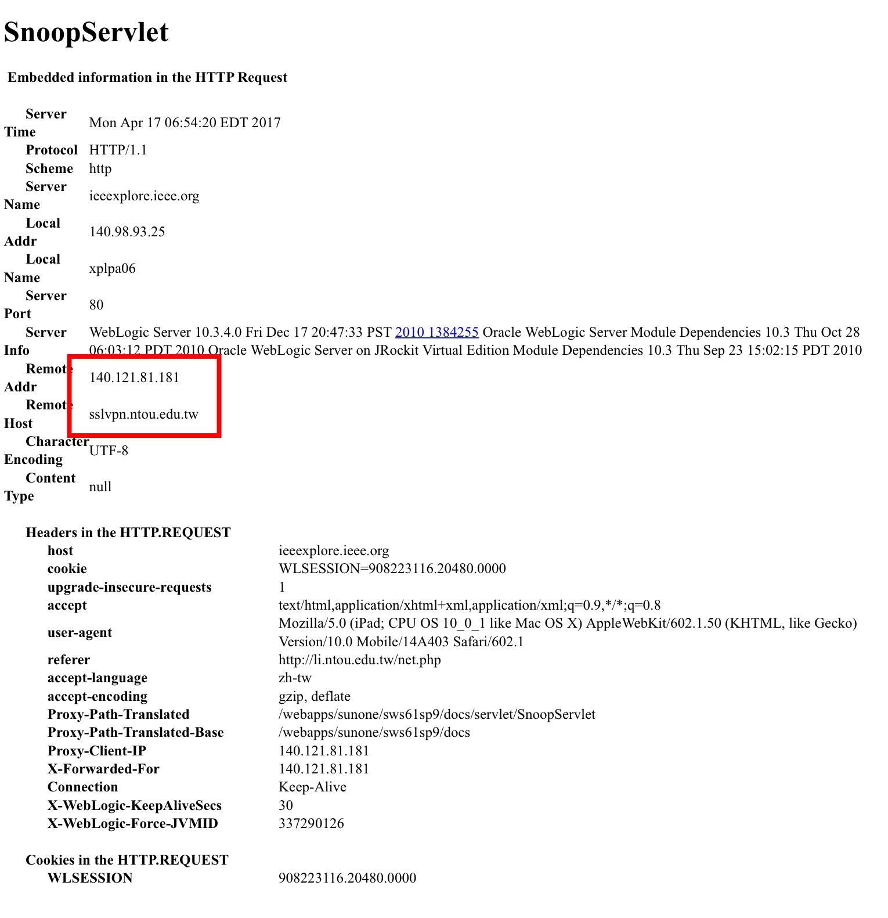

Step6：E-Resources -> Setting up Off-campus Access -> IP Check ，Connect success.

